

**Community Health Education**

**A Virtual Program**

**Do you experience** [**dizzy spells**](http://www.webmd.com/first-aid/understanding-dizziness-basics)

**that make you feel as though you are spinning?**

**Or that the world around you is spinning?**

**This sensation of spinning,**

**Is it Vertigo?**

**Thursday, Feb 25, 2021**

**1pm**

**RWJUH proudly presents:**

**Anita Bhandarkar**

**Au.D., CCC-A**

**Senior Audiologist**

**RWJUH Dept of Speech & Hearing**

**Join our discussion with Dr. Bhandarkar**

**To learn:**

* **What causes vertigo?**
* **What are the risk factors?**
* **What are the signs and symptoms?**
* **How is vertigo diagnosed?**
* **The treatment for vertigo?**

**And answers your questions.**

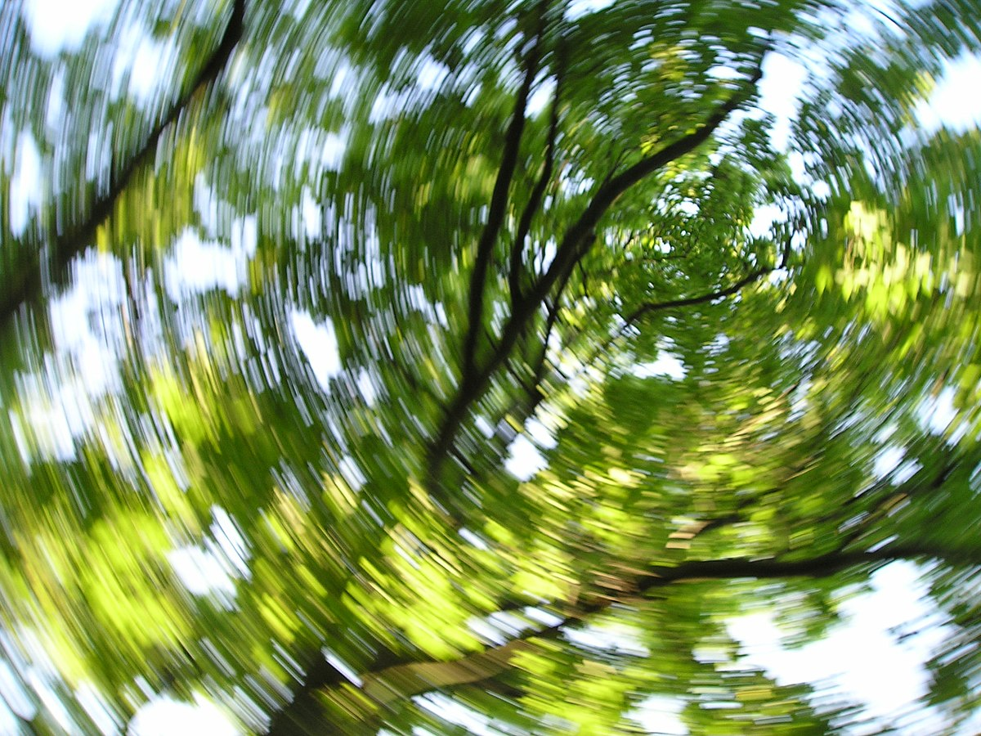

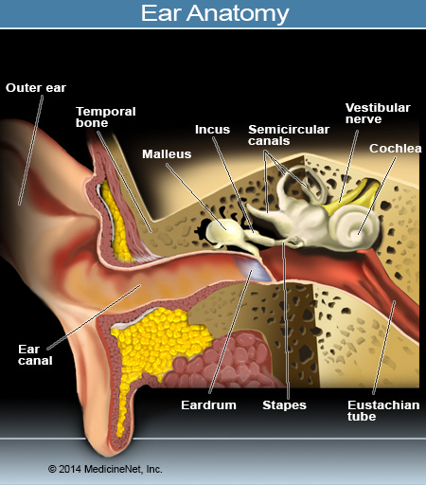

**To register for this program and to inquire about all of our virtual programs email**

[**kjohnson@rwjbh.org**](mailto:kjohnson@rwjbh.org) **or** [**susan.capolongo@rwjbh.org**](mailto:susan.capolongo@rwjbh.org)

**or** [**susan.capolongo@rwjbh.org**](mailto:susan.capolongo@rwjbh.org)